**Exercise 01**

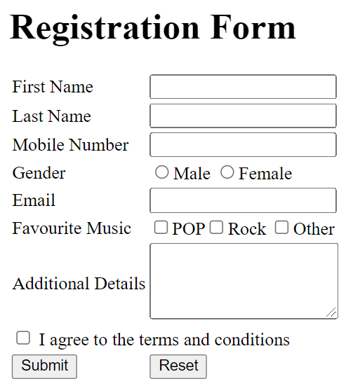Write down the HTML code required to create the following form.

<html>

<head>

<title> Registration Form </title>

<style>

input {

margin: 10px;

}

body {

border: 2px solid black;

padding: 10px;

margin-top: 50px;

margin-left: 50px;

margin-right: 770px;

margin-bottom: 580px;

}

</style>

</head>

<body>

<h1> Registration Form </h1>

<form>

<table>

<tr>

<td> First Name </td>

<td>

<input type="text">

</td>

</tr>

<tr>

<td> Last Name </td>

<td>

<input type="text">

</td>

</tr>

<tr>

<td> Mobile Number </td>

<td>

<input type="email" name="">

</td>

</tr>

<tr>

<td> Gender </td>

<td>

<input type="radio" value="Male"> Male <input type="radio" value="Female"> Female

</td>

</tr>

<tr>

<td> Email </td>

<td>

<input type="email">

</td>

</tr>

<tr>

<td> Favourite Music </td>

<td>

<input type="checkbox" value="POP"> POP

<input type="checkbox" value="Rock"> Rock

<input type="checkbox" value="Other"> Other

</td>

</tr>

<tr>

<td> Additional Details </td>

<td>

<textarea name="" rows="8" cols="25"> </textarea>

</td>

</tr>

<tr>

<td>

<input type="checkbox" value="text"> I agree to the terms and conditions </td>

</tr>

<tr>

<td>

<input type="submit"> <input type="reset">

</td>

</tr>

</table>

</form>

</body>

</html>

**Exercise 02**

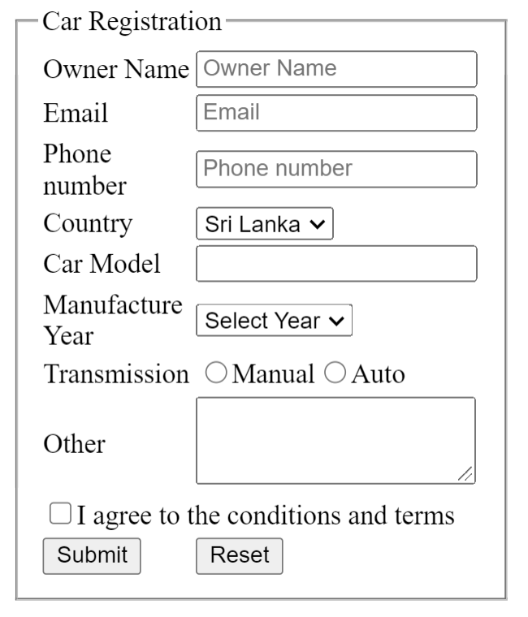

<html>

<head>

<title> Car Registration </title>

<style>

body {

width: 35%;

margin: 30px auto;

}

fieldset {

border: 1px solid grey;

}

legend {

font-size: 25px;

font-weight: 600;

}

</style>

</head>

<body>

<form>

<fieldset>

<legend> Car Registration </legend>

<table>

<tr>

<td> Owner Name </td>

<td>

<input type="text" name="" placeholder="Owner Name">

</td>

</tr>

<tr>

<td> Email </td>

<td>

<input type="email" name="" placeholder="Email">

</td>

</tr>

<tr>

<td> Phone number </td>

<td>

<input type="tel" name="" placeholder="Phone Number">

</td>

</tr>

<tr>

<td> Country </td>

<td>

<select>

<option> Sri Lanka </option>

</select>

</td>

</tr>

<tr>

<td> Car Model </td>

<td><input type="text" name=""></td>

</tr>

<tr>

<td> Manufacture Year </td>

<td>

<select>

<option> Select Year </option>

</select>

</td>

</tr>

<tr>

<td> Transmission </td>

<td>

<input type="radio" name="" value="Manual"> Manual

<input type="radio" name="" value="Auto"> Auto

</td>

</tr>

<tr>

<td> Other </td>

<td>

<textarea name="other" rows="5" cols="23"> </textarea>

</td>

</tr>

<tr>

<td>

<input type="checkbox" value="text"> I agree to the conditions and terms </td>

</tr>

<tr>

<td>

<input type="submit"> <input type="reset">

</td>

</tr>

</table>

</fieldset>

</form>

</body>

</html>